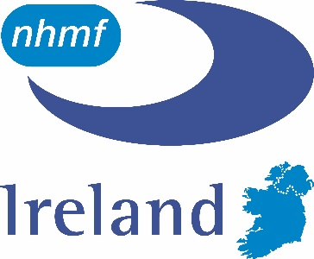
NHMF Ireland Branch

Meeting Agenda

Wednesday 18th October 2017

11:45am @ Northern Ireland Housing Executive DLO, 1A Annagh Hill, Thurdergee Road, Portadown, BT62 3BT
11:30am - Tour of NIHE DLO Premises, Presentation on Service Delivery and Use of Technology in Repairs.
12:30 - Working Lunch & Committee Meeting
- Welcome
- Minutes of Previous Meeting held on 21 June 2017
- Matters Arising
- Contract Issues and Procurement
- Direct Labour
- Training
- Benchmarking
- Health & Safety
- Nomination to NHMF Schedule of Rates Steering Committee
- NHMF Study Tour London 8-10th November 2017
- NHMF Conference 23-24th January 2018, Birmingham
- Date and Time of Next Meeting

Meeting to be concluded by 14:15 so trains can be caught back to Dublin
*Train from Dublin leaves 9:30 and arrives in Portadown 11.08
*Train from Portadown leaves 14.41 and arrives in Dublin 16:20

